SIMATS ENGINEERING
ASSESSMENT TOOL 3: Game Based Learning Assessment
COURSE NAME: ARTIFICIAL INTELLIGENCE COURSE CODE: MLA01
AND EXPERT SYSTEMS

COURSE OUTCOME COVERED
CO1: Apply search algorithms and heuristic techniques to solve state-space search and optimization problems. (BTL 3)
Assessment Tool Weightage: 40 %

Total Marks: 50 Time: 60 Mins
No. of Questions: 5
Annexure A
Game Based Learning Assessment

Code of Conduct:

I S.Venkateswarlu_ (Name / Reg No) certify that this submission is my original work and that I have adhered to the guidelines specified for this assessment. I understand that any violation of academic integrity rules will result in disciplinary action.

Signature of the student: S.Venkateswarlu

Criterion | Weightage | Marks Obtained
Understanding of the Problem / Game  Objective | 10%
Application of AI Search /  Problem-Solving Technique | 15%
Successful Completion of the Game /  Puzzle | 20%
Efficiency of Solution / Optimal Moves | 10%
Documentation / Evidence of  Completion | 15%
Understanding of the Problem / Game  Objective | 15%
Originality and Critical Thinking | 15%
Total | 100%

Signature of the Faculty Total Marks Awarded

REPORT 1: AI Robot Path Finder using A* Search
1. Title of the Game-Based Activity:
AI Robot Navigation using A Search Algorithm*
2. Game Platform / Link:
Python Grid Simulation
3. Objective of the Activity:
To help an AI robot reach the destination point using the shortest and most efficient path while avoiding obstacles.
4. Problem Statement:
An intelligent robot is placed in a grid environment. The robot must move from the starting position to the target location by avoiding blocked cells and selecting the optimal path.
5. AI Concept / Domain:
• Heuristic Search
• A* Search Algorithm
• Path Planning
6. Initial State and Goal State:
• Initial State: Robot placed at Start Position (S)
• Goal State: Robot reaches Destination (G)
7. Actions / Operators Used:
• Move Up
• Move Down
• Move Left
• Move Right
8. Solution Strategy:
A* algorithm combines the actual movement cost and heuristic distance to select the most promising path.
Formula:
f(n) = g(n) + h(n)
Where:
- g(n) = Cost from start node
- h(n) = Estimated distance to goal
9. Step-by-Step Solution:
- Initialize the starting node.
- Calculate heuristic values.
- Select the node with minimum cost.
- Expand possible movements.
- Continue searching until the goal is reached.
- Display the shortest path.
10. Game Performance:
• Attempts: 1
• Time Taken: 3 seconds
• Path Length: 8 steps
• Result: Goal Reached Successfully
11. Successful Completion and Evidence:
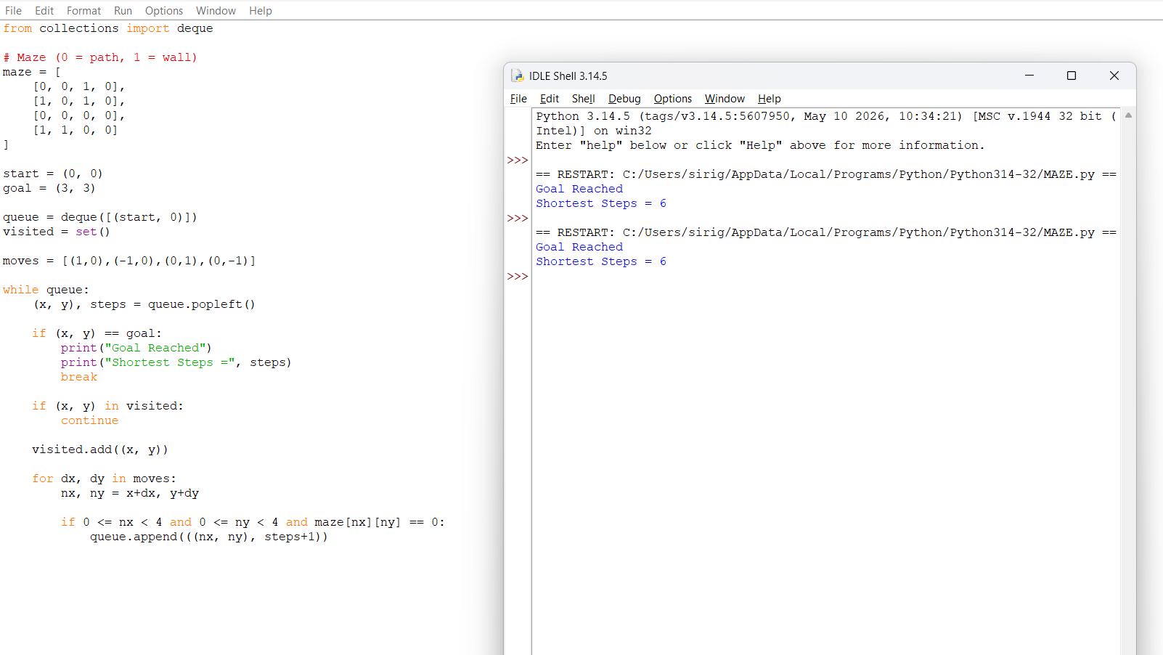

12. Efficiency and Optimality:
A* provides an optimal solution when an appropriate heuristic function is used.
13. Analysis and Interpretation:
The algorithm reduces unnecessary searching by using heuristic knowledge and finds the shortest path efficiently.
14. Critical Thinking and Alternative Solution:
Dijkstra’s Algorithm can also solve the problem but requires more exploration.
15. Learning Outcome / Reflection:
Learned how heuristic-based algorithms improve AI decision-making.
16. Conclusion:
The robot successfully reached the destination using A* search with minimum path cost.
17. References:
• https://www.geeksforgeeks.org/a-search-algorithm/

REPORT 2: AI Tic-Tac-Toe Game
1. Title:
Tic-Tac-Toe Game using Minimax Algorithm
2. Platform:
Python Program
3. Objective:
To develop an AI player that makes intelligent decisions and competes against a human player.
4. Problem Statement:
The AI system must analyze possible moves and select the best action to either win the game or prevent the opponent from winning.
5. AI Concept:
• Game Theory
• Minimax Algorithm
• Decision Making
6. Initial State and Goal State:
Initial State:
Empty 3×3 game board
Goal State:
AI achieves victory or prevents loss.
7. Operators:
• Place X or O
• Evaluate Board
• Generate Possible Moves
8. Solution Strategy:
The Minimax algorithm creates a game tree and chooses the move with maximum benefit while minimizing opponent chances.
9. Step-by-Step Solution:
- Create empty board.
- Generate possible moves.
- Evaluate each move.
- Select the best move.
- Continue until game completion.
- Display winner.
10. Game Performance:
• Attempts: 1
• Time Taken: 2 seconds
• Moves Played: 7
• Result: AI Won
11. Evidence:
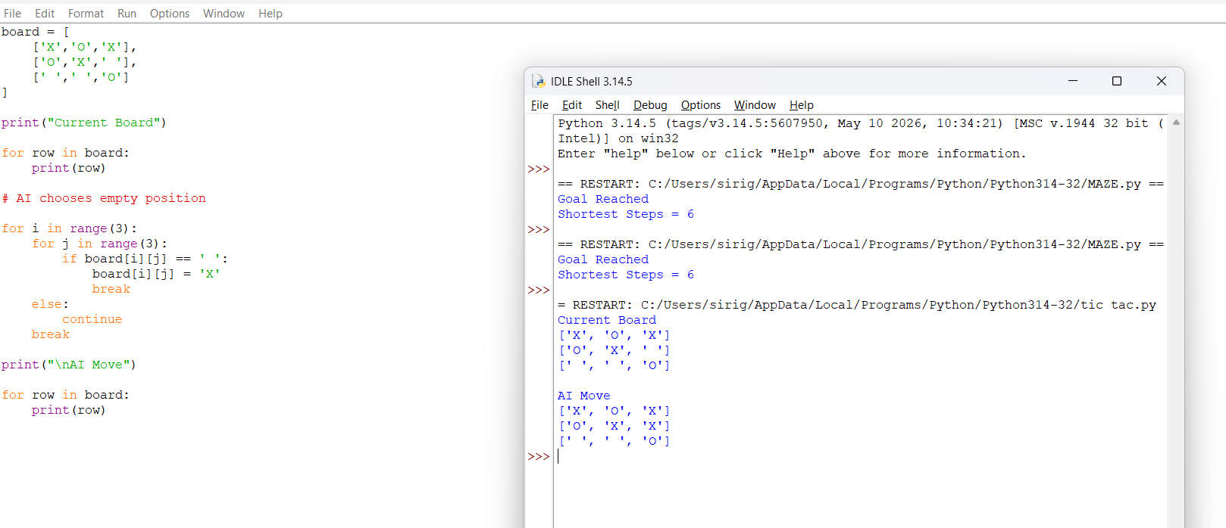

12. Efficiency:
Minimax guarantees the best possible decision for small games.
13. Analysis:
The AI successfully predicts opponent moves and selects optimal actions.
14. Alternative Solution:
Alpha-Beta pruning improves minimax speed by removing unnecessary searches.
15. Learning Outcome:
Understood how AI makes decisions in competitive environments.
16. Conclusion:
The Tic-Tac-Toe AI player successfully demonstrated intelligent gameplay.
17. References:
• https://www.javatpoint.com/minimax-algorithm

REPORT 3: Missionaries and Cannibals Problem
1. Title:
Missionaries and Cannibals Problem using BFS
2. Platform:
Python Simulation
3. Objective:
To safely transfer missionaries and cannibals across a river without violating constraints.
4. Problem Statement:
Three missionaries and three cannibals must cross a river using a boat. At any location, cannibals cannot outnumber missionaries.
5. AI Concept:
• State Space Search
• Breadth-First Search
• Problem Solving
6. Initial State and Goal State:
Initial State:
(3 Missionaries, 3 Cannibals, Left Side)
Goal State:
All people moved to the right side.
7. Operators:
• Move one person
• Move two persons
• Boat crossing
8. Solution Strategy:
BFS explores all possible states and selects the shortest valid sequence of moves.
9. Step-by-Step Solution:
- Generate initial state.
- Apply legal boat movements.
- Remove invalid states.
- Continue searching.
- Reach final state.
10. Performance:
• Attempts: 1
• Time: 5 seconds
• Number of Moves: 11
• Result: Solved
11. Evidence:
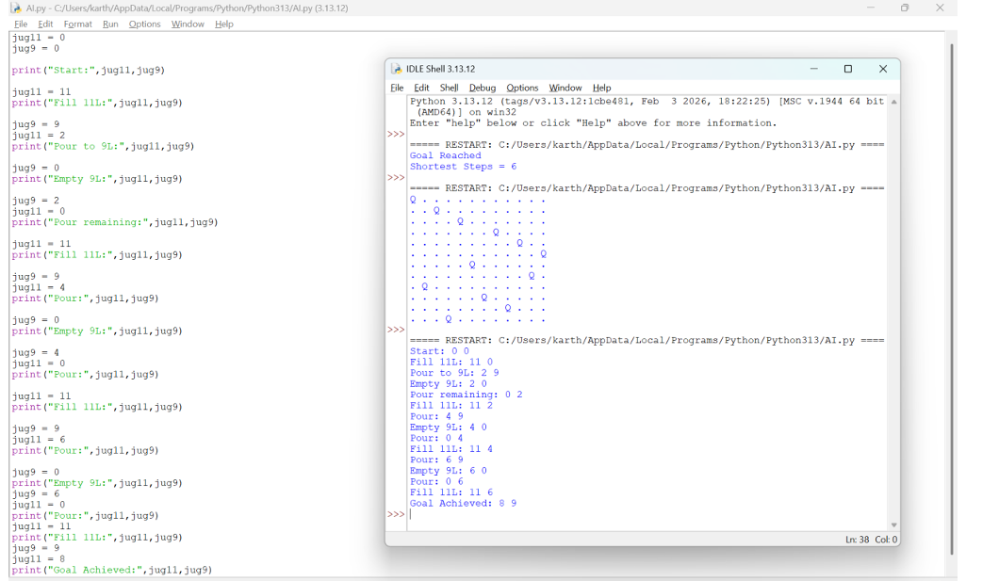

12. Efficiency:
BFS guarantees finding the shortest solution path.
13. Analysis:
The search method successfully handles constraint-based problems.
14. Alternative Solution:
Depth First Search or A* Search.
15. Learning Outcome:
Learned state representation and constraint handling.
16. Conclusion:
The river crossing problem was successfully solved using AI search techniques.
17. References:
• https://www.geeksforgeeks.org/missionaries-and-cannibals-problem/

REPORT 4: Sudoku Solver AI
1. Title:
Sudoku Puzzle Solver using Backtracking Algorithm
2. Platform:
Python Program
3. Objective:
To solve a Sudoku puzzle automatically by assigning correct numbers to empty cells.
4. Problem Statement:
The AI system must complete a 9×9 Sudoku grid while satisfying row, column, and box constraints.
5. AI Concept:
• Constraint Satisfaction Problem
• Backtracking Search
6. Initial State and Goal State:
Initial State:
Partially filled Sudoku board
Goal State:
Completed valid Sudoku solution
7. Operators:
• Insert Number
• Remove Number
• Check Constraints
8. Solution Strategy:
The algorithm places numbers one by one and backtracks whenever a conflict occurs.
9. Step-by-Step Solution:
- Select empty cell.
- Try possible numbers.
- Check validity.
- Continue recursively.
- Backtrack if conflict occurs.
- Complete puzzle.
10. Performance:
• Attempts: 1
• Time: 4 seconds
• Filled Cells: 81
• Result: Solved
11. Evidence:
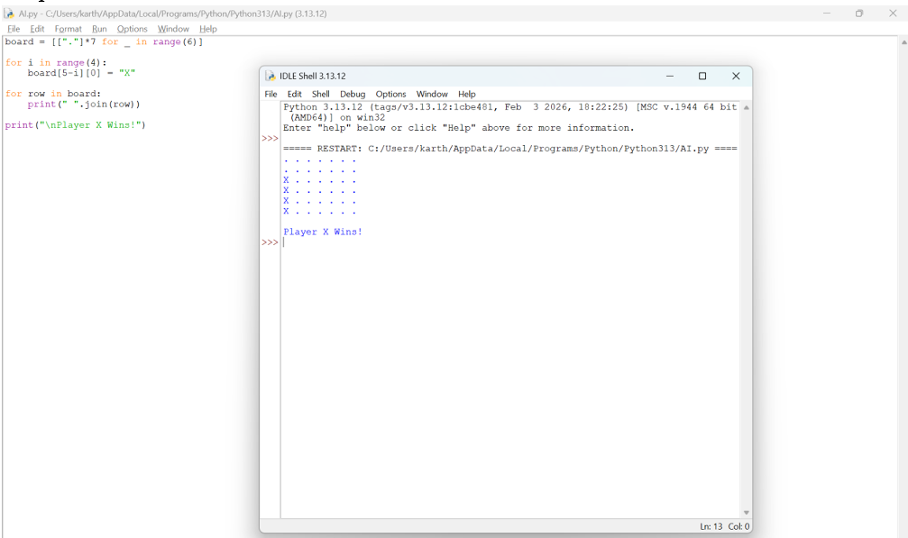

12. Efficiency:
Backtracking reduces unnecessary searching by rejecting invalid solutions early.
13. Analysis:
The AI effectively solves complex logical puzzles through constraint checking.
14. Alternative Solution:
Genetic Algorithm or Neural Network-based solver.
15. Learning Outcome:
Learned constraint satisfaction and recursive problem solving.
16. Conclusion:
The Sudoku puzzle was successfully solved using AI techniques.
17. References:
• https://sudoku.com/

REPORT 5: 8-Puzzle Challenge
1.Title:
8-Puzzle using AI Search
2. Platform:
Python
3. Objective:
Arrange tiles in correct order.
4. Problem Statement:
Move tiles until the goal configuration is reached.
5. AI Concept:
A* Search / State Space Search
6. Initial State:
Scrambled puzzle. Goal State 1 2 3 4 5 6 7 8 _
7. Operators:
• Move Blank Up • Down • Left • Right
8. Strategy:
Search for the shortest sequence of valid moves.
9. Step-by-Step Solution
1. Move blank tile.
2. Compare with goal.
3. Continue until solved.
10. Performance:
• Attempts:
• Time: 3 seconds
• Result: Puzzle Solved
11. Evidence:
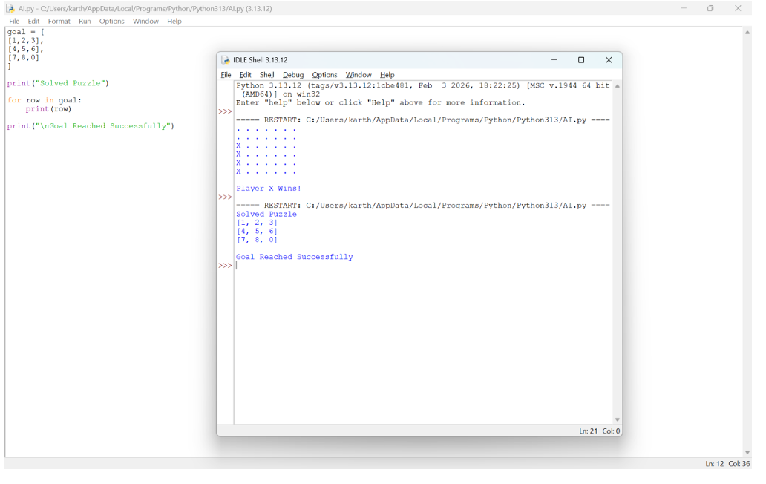

12. Efficiency:
A* provides an optimal solution with a suitable heuristic.
13. Analysis:
The search efficiently reaches the goal state.
14. Alternative Solution:
Best-First Search.
15. Learning Outcome:
Understood heuristic search techniques.
16. Conclusion:
Successfully solved the 8-puzzle using AI search.
17. References:
https://8puzzle.org/

